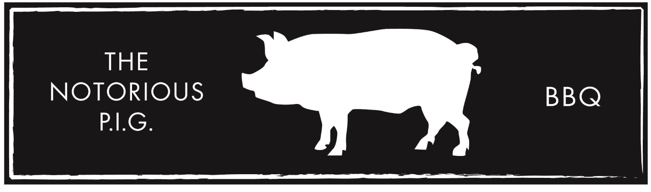OFF-SITE CATERING MENU
40 PERSON MINIMUM
ONE MEAT AND ONE SIDE: $16.50/PERSON
TWO MEATS AND TWO SIDES: $19.50/PERSON
THREE MEATS AND THREE SIDES: $22.50/PERSON
*TRI-TIP OR TWO-BONE RIB SERVING ADD $4.50/PERSON*

MEATS:
PULLED PORK, BRISKET, TURKEY,
TRI-TIP*, TWO-BONE RIB SERVING*

SIDES:
PIT BAKED BEANS, COLE SLAW, DEVILED EGG POTATO SALAD, APPLE SAUCE

ALL CATERING INCLUDES:
PLATES, CUTLERY, SERVING UTENSILS, NAPKINS, CHAFING DISHES, BREAD, SAUCE, DELIVERY, & SET UP.
*DELIVERY CHARGE: FIRST 20 MILES FREE. $1.50/MILE AFTER ON THE WAY THERE.*
*2 SERVICE AND CLEAN UP STAFF AVAILABLE FOR $200 FOR UP TO 3 HOURS.*
PLEASE ALLOW 72 HOURS NOTICE
FOR CATERING INFO PLEASE CALL TOM HOLMES AT 314.799.5770 OR EMAIL CATERING@THENOTORIOUSPIGBBQ.COM

